Security policies and model

What is a Security Model?
• A model describes the system – e.g., a high level specification or an abstract machine description of what the system does
• A security policy
– defines the security requirements for a given system
• Verification techniques that can be used to show that a policy is satisfied by a system
• System Model + Security Policy = Security Model

Information Flow Models
In reality, there are state transitions
Key is to ensure transitions are secure
Models provide rules for how information flows from state to state
State Machine Model State is a snapshot of the system at one moment in time.
State transition is the change to the next state.
If all the state transitions in a system are secure and if the initial state of the system is secure, then every subsequent state will also be secure, no matter what input occurs

Bell-Lapadula Model
The Bell-Lapadula Model of protection systems deals with the control of information flow. It is a linear non-discretionary model. This model of protection consists of the following components:
- A set of subjects, a set of objects, and an access control matrix.
- Several ordered security levels. Each subject has a clearance and each object has a classification which attaches it to a security level. Each subject also has a current clearance level which does not exceed its clearance level. Thus a subject can only change to a clearance level below its assigned clearance level.
The set of access rights given to a subject are the following:
- Read-Only: The subject can only read the object.
- Append : The subject can only write to the object but it cannot read.
- Execute : The subject can execute the object but can neither read nor write.
- Read-Write: The subject has both read and write permissions to the object.
Control Attribute: This is an attribute given to the subject that creates an object. Due to this, the creator of an object can pass any of the above four access rights of that object to any subject. However, it cannot pass the control attribute itself. The creator of an object is also known as the controller of that object.
Restrictions imposed by the Bell-Lapadula Model:
The following restrictions are imposed by the model:
- reading down: A subject has only read access to objects whose security level is below the subject's current clearance level. This prevents a subject from getting access to information available in security levels higher than its current clearance level.
- writing up: A subject has append access to objects whose security level is higher than its current clearance level. This prevents a subject from passing information to levels lower than its current level.
The Bell-Lapadula model supplements the access matrix with the above restrictions to provide access control and information flow. For instance, if a subject has read access to an object in the access matrix, it may still not be able to exercise this right if the object is at a security level higher than its clearance level.
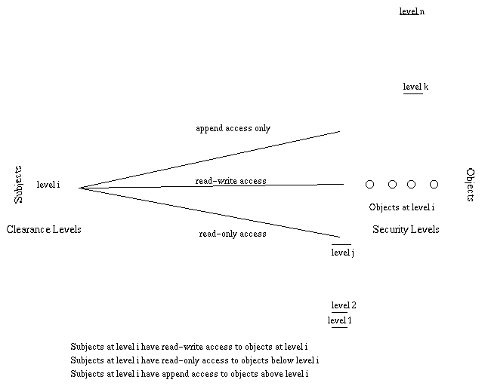
Bell and Lapadula modeled the behavior of a protection system as a finite state machine and defined a set of state transitions that would not violate the security of the system. The following operations gaurantee a secure system:
- get access: Used by a subject to initiate access to an object (read, append, execute etc )
- release access: Used by a subject to giveup an initiated access.
- give access: Controller of an object can give a particular access (to that object) to a subject.
- rescind access: Controller of an object can revoke a designated access ( to that object) from a subject.
- create object: Allows a subject to activate an inactive object.
- delete object: Allows a subject to deactivate an active object.
- change security level:Allows a subject to change its clearance level ( below an initial assigned value)
However certain conditions have to be satisfied before the above operations can be performed. For instance, a subject can exercise give and rescind rights to an object only if it has control attributes to that object.
Bell-Lapadula is a simple linear model that exercises access and information flow control through the above restrictive properties and operations. However, it has a disadvantage of security levels of objects being static. The properties of this model might become too restrictive in cases when certain operations are outside the context of protection system.
Questions
1) What is the effect of reading down and writing up restrictions imposed by the Bell-Lapadula model?
2) Why is a subject's current clearance level only lower than its initial assigned clearance level ?
3) Write down the conditions to be satisfied for each of the seven operations to be executed.
4) Why is the Bell-Lapadula model a non-discretionary one?

Bell-LaPadula Model
- The Bell-LaPadula Model of protection systems deals with the control of information flow. It is a state machine model used for enforcing access control in government and military applications.
- It is an inflexible, formal, state transition model describing MAC rules and supporting multi-level security.
- Here, subjects & objects are assigned a security class which controls the manner in which a subject can be accessed by an object.
- This model uses an Access matrix of subjects & labelled objects .
- Each subject has a “security clearance” & each object has a “security classification”.
- Subject classes form a strict hierarchy called “security levels”. These security levels are,
- Top Secret (Maximum Security) > Secret > Confidential > Unclassified (Lowest Security)

Properties of Bell-LaPadula Model

1. The Simple Security Property (No Read Up)
- The Simple Security Property states that, “A subject at a given security level may not read an object at a higher security level”.

2. The Star Property (No Write Down)
- The Star Property states that, “A subject at a given security level may not write to any object at a lower security level”.

3. The Strong Star Property
- The Strong Star Property states that, “A subject can perform read & write capabilities only on those functions present at the same security level”. ( i.e A subject in one classification level cannot read or write to any other classification level)

Advantages :
- This model resists Trojan horse attack.
- Since, this the model focuses on confidentiality & controlled access to classified information, it is used in military & mission critical applications.

Disadvantage :
- Bell-LaPadula model emphasizes only confidentiality; does not address the issue of data integrity.
- It does not have any inherent policies for changing the access rights.
- It is primarily intended for largely static security levels.

Biba Model
- Biba model is a formal, state transition model, describing set of access control rules in order to ensure integrity.
- Data and subjects are ordered by their levels of integrity into groups or arrangements.
- Integrity assures that the data is not altered during transit. This is the first model that dealt with data integrity.
- The model is designed so that subjects may not corrupt data in a level ranked higher than the subject, or be corrupted by data from a lower level than the subject.
- Biba model is an information flow model since it is concerned with data flow from one level to another.
- Here, the subjects & objects are ordered by their level of integrity into groups, where, the level of integrity is proportional to the impact of data integrity loss in an organization.
Level of Integrity | Weight | Impact of loss of data integrity
Not Applicable | 0 | Low
Approximate | 3 | Moderate
Exact | 6 | High
Data Integrity table

Properties of Biba Model

1. The Simple Integrity Property (No Read Down)
- The Simple Integrity Property states that, “A subject at a given level of integrity must not read data at a lower integrity level”.

2. The Star Integrity Property (No Write Up)
- The Star Integrity Property states that, “A subject at a given level of integrity must not write to data at a higher level of integrity”.

3. Invocation Property
- The Invocation Property states that, “A subject at one level of integrity cannot cannot request access to a subject at a higher level”. (Only with subjects at an equal or lower level)

Advantages :
- This model is simple & easy to implement.
- Dynamic policies can be implemented.
- It provides a number of different policies that can be selected based on needs.

Disadvantage :
- It does not enforce confidentiality.
- Labelling of integrity should be supported.
- Does not support Grant, Revoke authorization.

David Clark and David Wilson (1987) argued that commercial
security has its own unique concerns and merits a model crafted
for that domain.
The overriding concern is consistency among the various
components of the system state.
Example: In a bank, the funds at the beginning of the day plus
the funds deposited minus the funds withdrawn should equal funds

on hand at the end of the day.

The Clark-Wilson Model

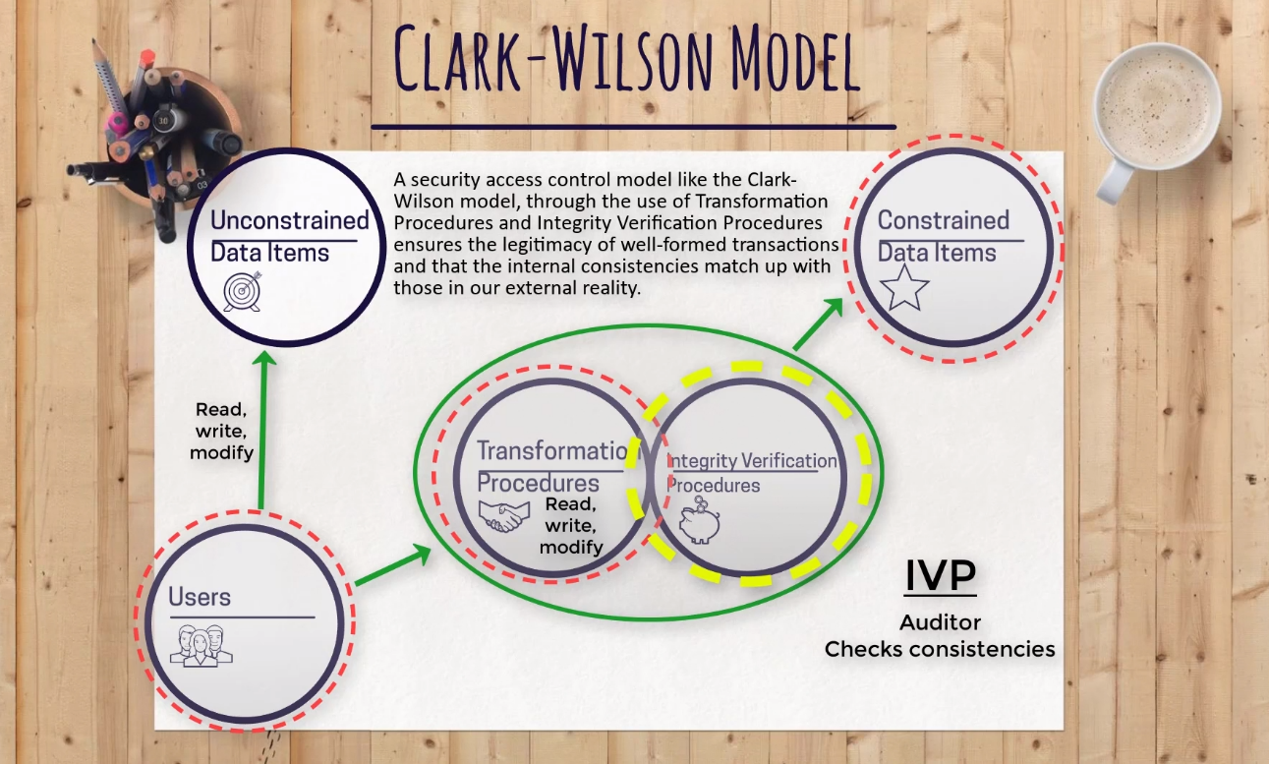
The Clark-Wilson model is for upholding integrity. Just like the Biba Model – which is also for upholding integrity. They're not for confidentiality. That’s what the Bell-LaPadula model is for. And it’s not availability. That’s what backups, high-availability firewalls, offsite storage, hot sites, cold sites, warm sites are for. But, you know, those aren’t really access control models like The Bell or Biba Model, they're just controls.
Clark-Wilson and Biba High Level Goals
At a high-level, both the Clark-Wilson Model and the Biba Model want to do the following three things:
First, they don’t want unauthorized users making changes within a system.
Even if a change occurs by a single letter, number, or character it has lost all integrity. Unless, it was meant to be changed. If it wasn’t meant to be changed, then it has truly lost integrity. This is one of the core goals of the Biba and Clark Wilson access control model, to prevent unauthorized modifications to data. To consistently maintain its integrity.
Second, the Biba and Clark Wilson Model uphold integrity by making sure that authorized users aren’t making unauthorized changes.
As in, yes the user is authorized to make changes, but the user can’t make changes which change the integrity of a file, object or resource. Meaning, they don’t do something accidentally or even intentionally, (even though they are authorized), to mess up the integrity of a system. Even the good guys can destroy a system by making mistakes. Biba and Clark Wilson try to lessen that risk.
Third, they both make sure internal and external consistency is maintained.
It’s a little confusing for me because it sounds like something a financial accountant would know more about for some reason.
Internal consistency is making sure that numbers which are supposed to add, actually add and numbers which are supposed to be multiplied, are actually multiplied and not added. Internal transactions do what they are supposed to do.
As for external consistency, that’s when someone like an investment banker tells his or her client that they sold 1000 shares of stock, and actually did sell 1000 shares of their stock. The banker didn’t tell their customer they sold a 1000 shares of their stock, but in actuality winded up selling only 900 and pocketing the rest of the money.
These internal and external consistency things are a way to maintain integrity, and to keep the systems and people in place honest.
What we just talked about are the high-level concepts of what these two models (Clark-Wilson & Biba) want to do as far as maintaining integrity, but not their specific implementation. That’s where they are different. They both want to uphold integrity, but they both go about doing it in different ways. That’s what we have to know for the CISSP exam.
The Biba Model has these three rules:
No Write Up Rule, which says a subject can’t write data to an object at a higher integrity level.
No Read Down Rule, which states a subject cannot read data located at a lower integrity level.
The Invocation Rule where a subject can’t request a service at a higher integrity level (depending on classification level: Top Secret/Secret/Confidential).
Those are all the rules of the Biba model. A model which upholds integrity. It is used to prevent data from being changed.
The Clark-Wilson Model does the same thing, but it does so in a completely different way.
With Clark-Wilson, instead of using integrity levels like in the Biba model, it uses a stringent set of change control principles and an intermediary.
The beauty of the Clark-Wilson model is that if a subject is trying to access an object, it does so without having a direct connection to it - without having direct access to the object. It takes external entities in order to prove and provide the necessary security. It requires what is known as a well-formed transaction.
Clark-Wilson Model
Users.
It all starts with users, otherwise known as the subjects. The subjects which will access the objects. Users are the ones that need the information. I think the books call users the “active agents”.
Transformation Procedures (TPs)
Then we have Transformation Procedures. Think of them as operations the subject is trying to perform. Is the subject trying to read a file? Write to a file? Or modify a file?
Transformation Procedures are simply operations which can be performed.
Constrained Data Items (CDIs)
There’s Constrained Data Items and Unconstrained Data Items. Objects which belong in the subset of Constrained Data Items are at a higher level of protection.
In a Clark-Wilson Model, there are two types of protections given to data items, constrained and unconstrained.
In order to read an object located in the Constrained Data Items subset, we have to go through a transformation procedure.
Constrained Data Items can only be manipulated by a Transformation Procedure.
Objects within a Constrained Data Items are so valuable, that in a Clark-Wilson model, a subject has to go through an intermediary to even just access it.
Unconstrained Data Items (UDIs)
Now objects in an Unconstrained Data Item subset, well they probably aren’t that important. These can be accessed by the subject directly, it doesn’t need to go through an intermediary like a Transformation Procedure. The subject can perform their own read and write operations without going through a Transformation Procedure.
Subjects access objects in a UDI like how they would normally access an object in a networked environment, as if they weren't using a Clark-Wilson Model. Like how we access files or objects in Windows operating systems.
Integrity Verification Procedures (IVPs)
Remember how we talked about internal and external consistency? That’s what Integrity Verification Procedures do, they check the internal and external consistency. IVPs are a way to audit the transformation procedure.
EXAM CONCEPTS
The Clark-Wilson Model enforces the concept of separation of duties. This is done through the Integrity Verification Procedures. When the IVP audits the well-formed transactions of the Transformation Procedures, the IVP is independently performing a duty separate from that of the Transformation Procedure. Separation of duties is performed when the IVP audits the Transformation Procedure.
And actually, you can also see the Separation of Duties principle when the Transformation Procedure accesses the Constrained Data Item on behalf of the subject. Duties are separated because it isn’t the job of the subject to access the CDI, but rather belongs to the Transformation Procedure.
The Clark-Wilson model is trying to separate a subject completely from an object in a CDI through the use of an intermediary. This separates duties so the subject cannot access the object directly, as it is not part of the subject's duty.
Another exam concept as we’ve said, Clark-Wilson upholds integrity through the use of well-formed transactions in the process of using Transformation Procedures.
Unlike the Biba model which uses integrity levels based on classifications.
the Clark-Wilson follows a trifecta for subject to object access.
Meaning it involves a subject, a program, and an object. Or a subject, a middleman, and an object.
Shon Harris calls this the Access Triple, where you have the user, which is the subject, a program in the middle which is the Transformation Procedures, and finally the object, which is the Constrained Data Item.
And another exam concept is that a constrained data item cannot be manipulated without first going through the program. Clark-Wilson uses Integrity Verification Procedures to verify and audit all transactions are done in a consistent manner and as they are supposed to be done.
The Clark-Wilson model is almost an improvement over the Biba Model I think because in order to make sure authorized subjects don’t make unintentional changes, there is always a middle-man in between the object and subject There is always a intermediary which makes sure that the transaction is solid, in other words, a well-formed transaction.

Bottom of Form

The Chinese Wall Security Policy

The 1989 Brewer and Nash published paper titled “The Chinese Wall Security Policy” is an authoritative voice in the information security realm. It is essentially an access control policy that addresses a very specific security issue: conflict of interest.
It aims to protect the confidentiality and, through extension, the integrity of a set of data, by mandating rules around its access and availability.
Data sets in the Brewer-Nash abstraction model could be any one of the following three types-
- Objects – This is the same as the objects of the Bell-LaPadula model and is essentially the ungrouped basic units of information
- Company Dataset – This is the collection of all objects belonging to a single organization or company
- Conflict of Interest Class – This is a collection of companies that are in competition with each other
Through a few axioms it can be inferred that if “Object 1” belongs to “Company 1” and “Object 2” belongs to “Company 2”, and if “Company 1” and “Company 2” belong to the same conflict of interest class, then all objects of “Company 1” are in conflict of interest with all objects of “Company 2”. So “Object 1” would be in conflict with “Object 2”.
The following could be considered as examples of conflict classes-
{Experian, Equifax, TransUnion}
{JP Morgan Chase, Bank of America, Citigroup}
{Google, Microsoft, Apple}
Now if “Person A” has access to some of Experian’s files, he cannot be granted access to any files of Equifax or TransUnion. However, he can be allowed access to Citigroup’s files. And if he is allowed this access, he cannot then further access any files belonging to JP Morgan Chase or Citigroup.
Thus it is seen that the access permissions in The Chinese Model are completely dependent on the history of access rights.
Brewer and Nash express their model in terms of two rules-
- The Simple Security rule – access can be permitted to an object if even one of the following two conditions are met-
  - The object is within the “Wall” i.e the object belongs to same company set.
If “Person A” has access to “Object 1” from Google, he can also be allowed access to “Object 2” from Google, or
  - The object belongs to an entirely separate conflict of interest class.
If “Person A” can access objects from Google, he can be granted access to objects from Bank of America
- *-Property rule or the Write Access rule – access for writing can be granted only if both the following conditions are met-
  - access is permitted by the above defined Simple Security rule, and
  - no object can be read if it is-
    - in a different company dataset than the one being written into, or
    - if the data is unsanitized
For example, if “Person A” wants to write an object in Google, and has access to Google and Bank of America, he is in accordance with the Simple Security rule, but he fails the *-Property rule and will not be allowed write into Google.
Further “Person B” who has access only to Google, and nothing else, satisfies both the Simple Security rule and the Write Access rule and can be granted permission to write a Google object.
On closer examination of the Simple Security rule, and on the understanding of how heavily access history weighs in The Chinese Wall policy, it is seen that while “Person A” can never compare Google’s datasets with Apple’s datasets, he also further never be allowed to compare Google’s datasets with Bank of America’s datasets, if he ever had had access to Apple’s datasets.
With the introduction of the concept of “sanitized” data, Brewer and Nash allow the relaxation of this stringent restriction. They define sanitized data as masked or disguised data that provide the facts but hides the identity of the company/organization.
For instance, if “Person A” had access to read only sanitized objects in “Apple” (implying that he did not know they belonged to Apple), then he can be allowed to compare datasets from Google with datasets from Bank of America.
In conclusion, it is obvious that the Chinese Wall model is starkly different from other security models. While the Biba Security Model, Lipner’s Security Model, and the Clark-Wilson Security Model are generic in nature, the Chinese Wall policy focuses on solving the very specific security concern of conflict of interest. It is further seen that the neither the Bell-LaPadula model nor role-based access controls cannot solve the conflict of interest security issues.
The legal mandate of the Chinese Wall security model in the realm of the United Kingdom Stock Exchange is a testimony of its effectiveness in preventing conflict of interest. The Brewer-Nash model can thus be adopted in commonplace business operations such as dealings with consultants and contractors and safeguard corporations from conflicts of interest.
Assignment
Explain how the above security models are implemented in MUST

